Software Design Document

**Document History**

|  |  |  |  |  |  |  |
| --- | --- | --- | --- | --- | --- | --- |
| **Document Name** | **Version** | **Status** | **Date** | **Viewable** | **Reviewer** | **Responsible** |
| iWish-SDD_V.0.1.docx | **Add**   * Introduction * Class Diagram * Class Description * DB * UI * SDW * SDA | Draft | 20-05-2015 | VC, SK, KS | VC, SK | VC, SK |
| iWish-SDD_V.1.docx | **Edit**   * Introduction * Class Diagram * Class Description * DB * UI * SDW * SDA | Release | 22-07-2015 | VC, SK, KS | VC, SK | VC, SK |

**\*VC = Visava Chumnuam**

**\*SK = Saksorn Khongsirirat**

**\*KS = Kittitouch Suteeca**

**Table of Contents**

1. Introduction 4

1.1 Project Overview 4

1.1.1 Purpose 4

1.1.2 Scope 4

1.1.3 Acronyms …………………………………………………………………………………………....4

2. System Architecture 5

3. Class Diagram 6

4. Class Description 8

5. Database Design 13

6. Sequence Diagram 14

7. User Interface 25

# **Introduction**

**1.1 Purpose**

The purpose of software design is designing the iWish’s system. The system has Android application and Web application. This document are contain about Class diagram, Database, User Interface, Sequence Diagram.

**1.2 Scope**

The application will be develop by Android studio.

* Focus on only one supermarket.
* Provide management system products in database.
* Provide android application for manage wish list.
* Convenient features for android application site.
  1. **Acronyms and Definition**

**Acronyms**

SDA Sequence Diagram Android

SDW Sequence Diagram Web

SK Saksorn Khongsirirat

SRSA System Requirement Specification Android

SRSW System Requirement Specification Web

UIA User Interface Android

UIW User Interface Web

VC Visava Chumnum

1. **System Architecture**

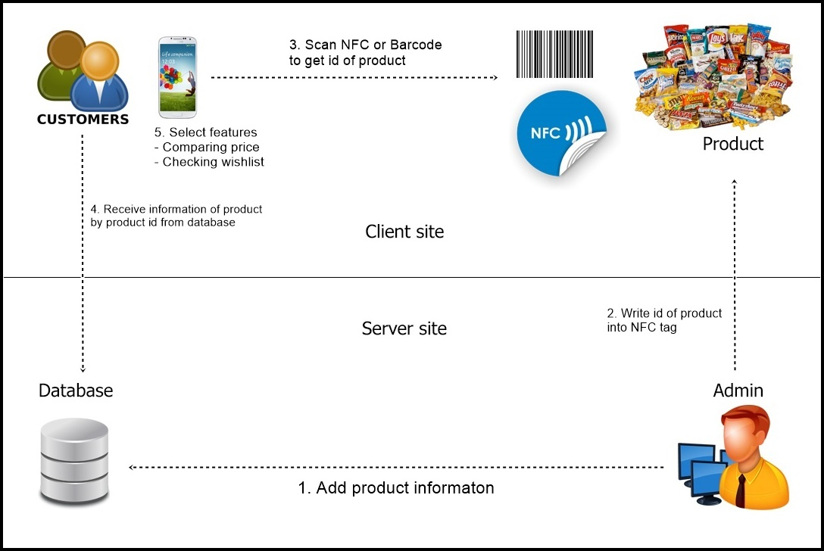

**Figure 20: Class Diagram Web**

1. **Class Diagram**

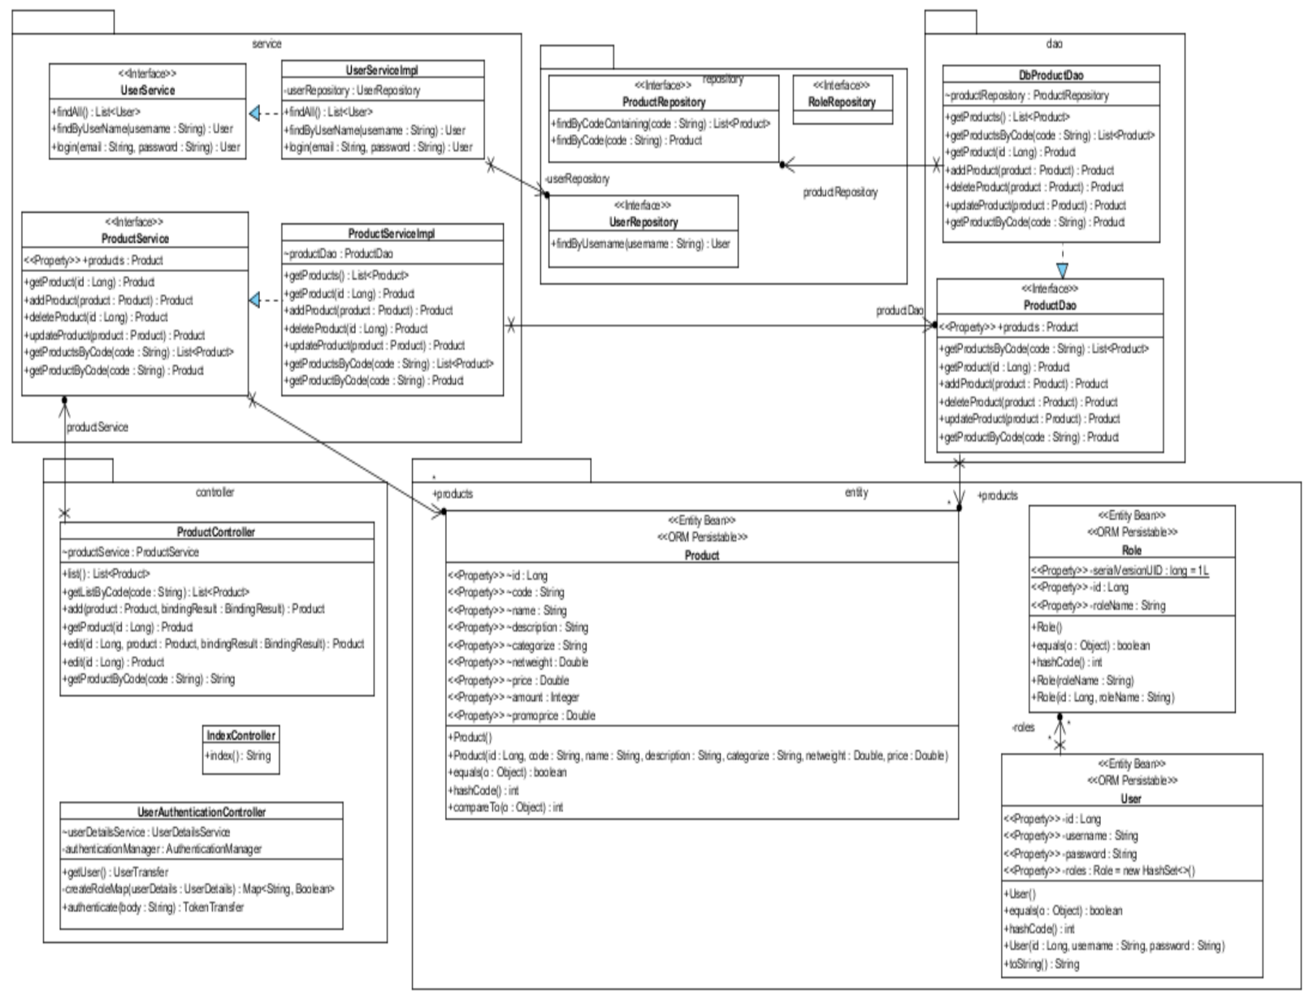

**Figure 21: Class Diagram Web**

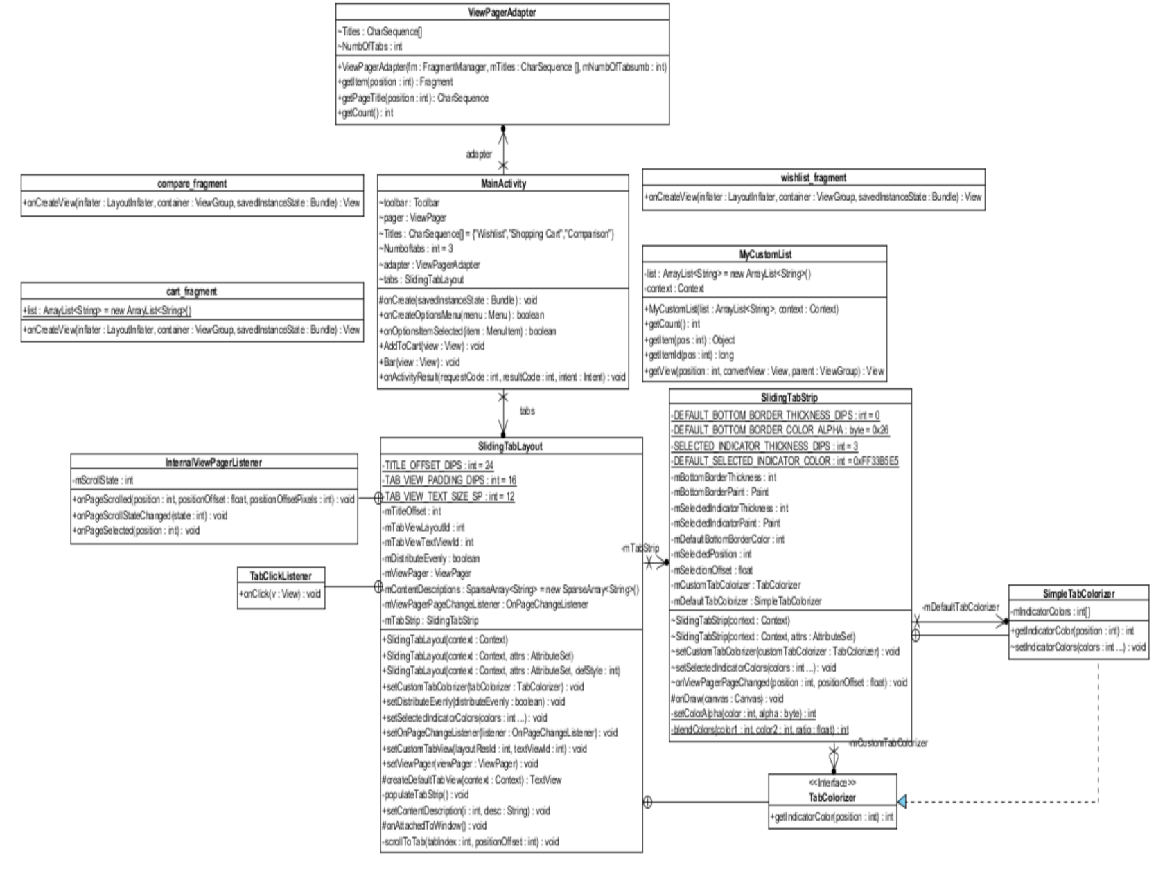

**Figure 22: Class Diagram Android**

1. **Class Description**

**Web Application**

**Controller package**

* 1. Class name: ProductController

|  |
| --- |
| **UserController** |
| -productService : ProductService |

**Property:**

|  |  |  |  |
| --- | --- | --- | --- |
| **ID** | **Name** | **Description** | **Remark** |
| 1 | productService | Object of ProductService, used for control feature about product. | **Type:** ProductService |

* 1. Class name: IndexController

|  |
| --- |
| **IndexController** |
| +index(): String |

**Method:**

|  |  |  |  |
| --- | --- | --- | --- |
| **ID** | **Name** | **Description** | **Remark** |
| 1 | index | Method for redirect to index page | **Return:** String |

**Service package**

* 1. Class name: UserServiceImpl

|  |
| --- |
| **UserServiceImpl** |
| **-**userRepository : UserRepository |
| + findByUserName(String username): User |

**Property:**

|  |  |  |  |
| --- | --- | --- | --- |
| **ID** | **Name** | **Description** | **Remark** |
| 1 | userRepository | Object of UserRepository, used for call feature of database about user. | **Type:** UserRepository |

**Method:**

|  |  |  |  |
| --- | --- | --- | --- |
| **ID** | **Name** | **Description** | **Remark** |
| 1 | findByUserName | Method for verify username in the system. | **Return:** User  **Param:** String |

* 1. Class name: ProductServiceImpl

|  |
| --- |
| **ProductServiceImpl** |
| **-**productDAO : ProductDAO |
| +deleteProduct(Long id): Product |

**Property:**

|  |  |  |  |
| --- | --- | --- | --- |
| **ID** | **Name** | **Description** | **Remark** |
| 1 | productDAO | Object of ProductDAO, used for call feature relate to database about Product. | **Type:** productDAO |

**Method:**

|  |  |  |  |
| --- | --- | --- | --- |
| **ID** | **Name** | **Description** | **Remark** |
| 1 | deleteProduct | Method for get right product to delete. | **Return:** Product  **Param:** Long |

**Web Application**

**Android Application**

* 1. Class name: MainActivity

|  |
| --- |
| **MainActivity** |
| -Titles : CharSequence[]  -Numboftabs : int  -editTextDialogUserInput : EditText  - buttonAddBar : Button |
| +AddToCart(View view): void  +Bar(View view): void  +onActivityResult(int requestCode, int resultCode, Intent intent) : void |

**Property:**

|  |  |  |  |
| --- | --- | --- | --- |
| **ID** | **Name** | **Description** | **Remark** |
| 1 | Titles | Used for specify title of page. | **Type:** CharSequence[] |
| 2 | Numboftabs | Used for specify number of page. | **Type:** int |
| 3 | editTextDialogUserInput | Edit text field used for input id of product. | **Type:** EditText |
| 4 | buttonAddBar | Button used for call barcode scanner feature. | **Type:** Button |

**Method:**

|  |  |  |  |
| --- | --- | --- | --- |
| **ID** | **Name** | **Description** | **Remark** |
| 1 | AddToCart | Method for show add product to cart by input product’s id. | **Return:** void  **Param:** View |
| 2 | Bar | Method for add product to cart by barcode scanner. | **Return:** void  **Param:** View |
| 3 | onActivityResult | Method for receive product’s id from barcode. | **Return:** void  **Param:** int, int, Intent |

* 1. Class name: MyCustomList

|  |
| --- |
| **MyCustomList** |
| -deleteBtn : Button  -addBtn : EditText |
| +deleteBtn.onClick(View view): void |

**Property:**

|  |  |  |  |
| --- | --- | --- | --- |
| **ID** | **Name** | **Description** | **Remark** |
| 1 | deleteBtn | Button used for call delete feature. | **Type:** Button |
| 2 | addBtn | Edit text field used for edit amount of product. | **Type:** EditText |

**Method:**

|  |  |  |  |
| --- | --- | --- | --- |
| **ID** | **Name** | **Description** | **Remark** |
| 1 | deleteBtn.onClick | Method for delete product from shopping cart. | **Return:** void  **Param:** View |

1. **Database Design**

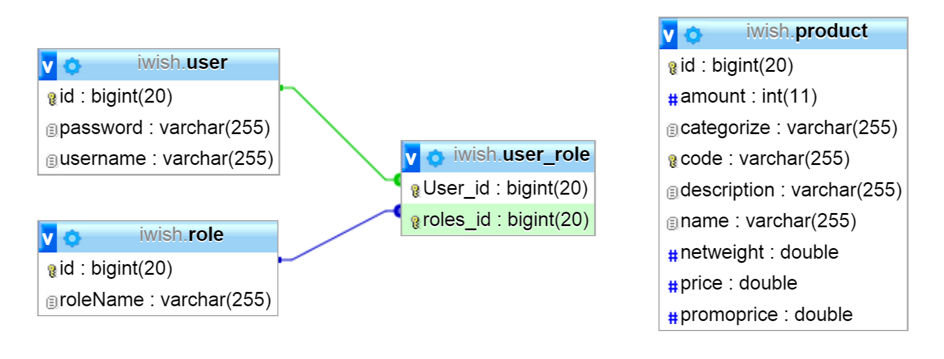

**Figure 23: Database Design**

1. **Sequence Diagram Web Application**

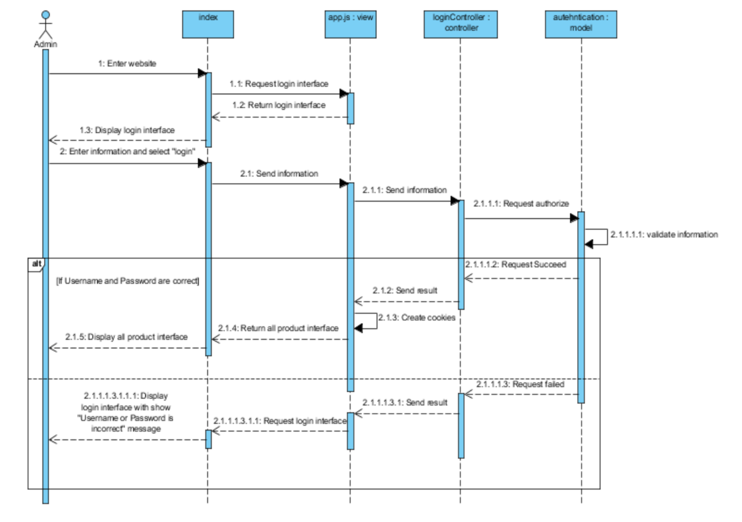

**Figure 24: SDW-01 Login**

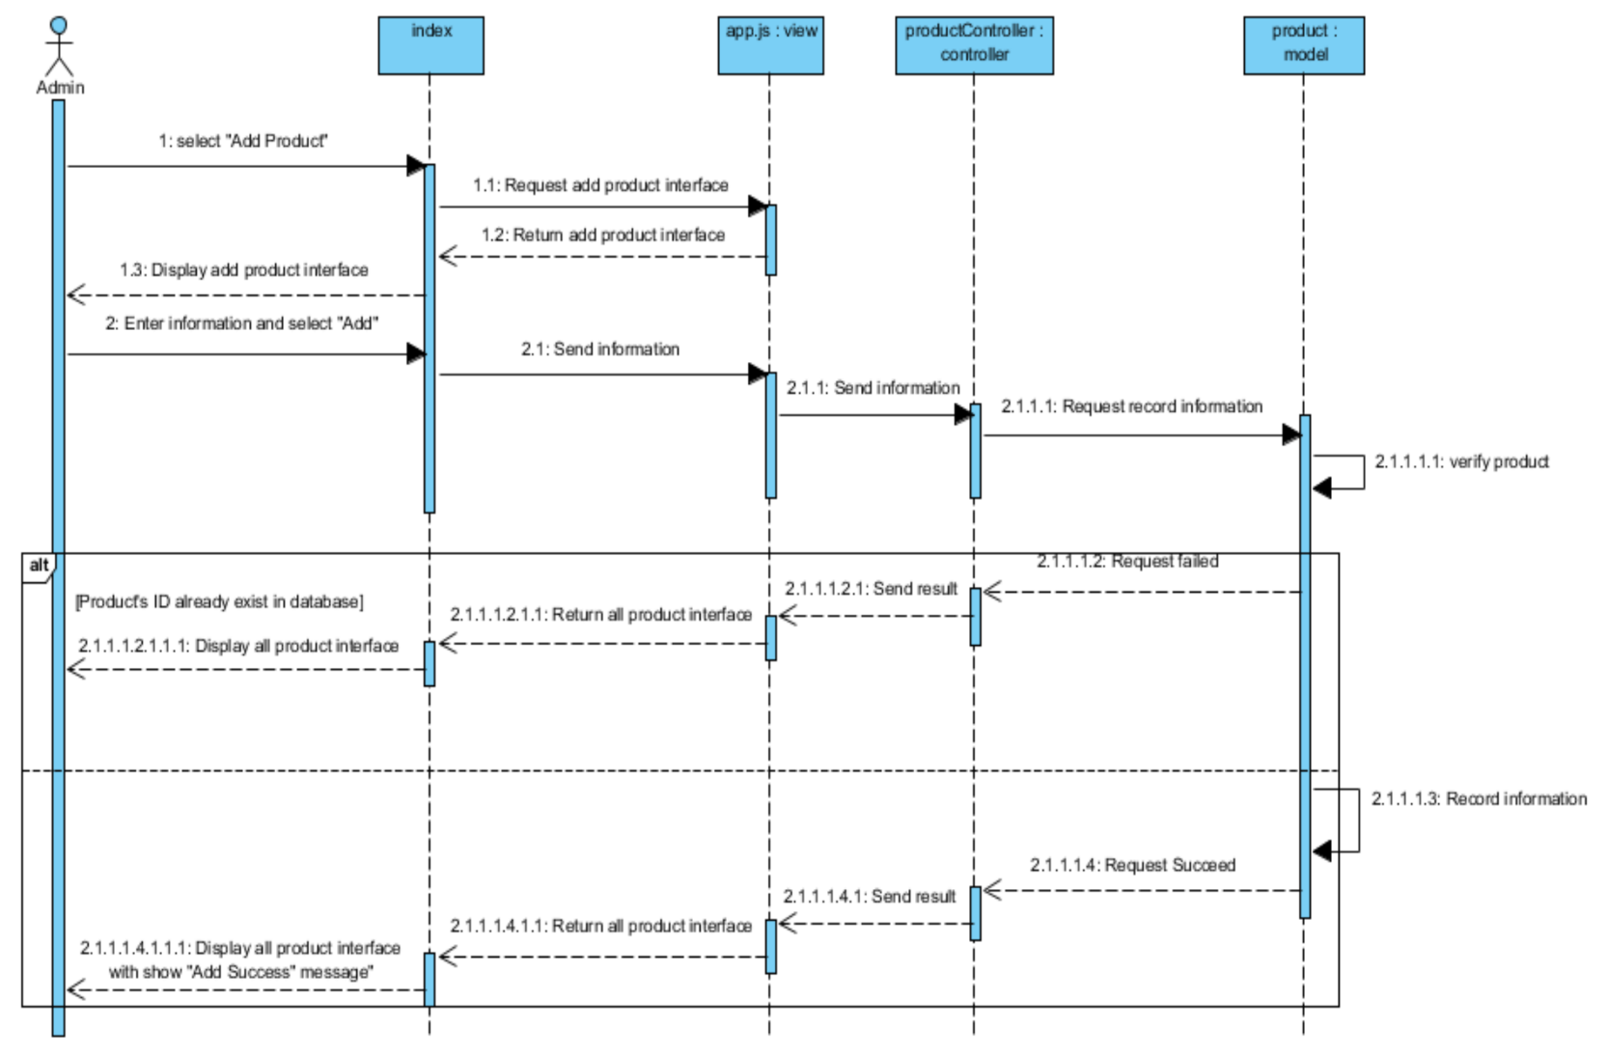

**Figure 25: SDW-02 Add New Product**

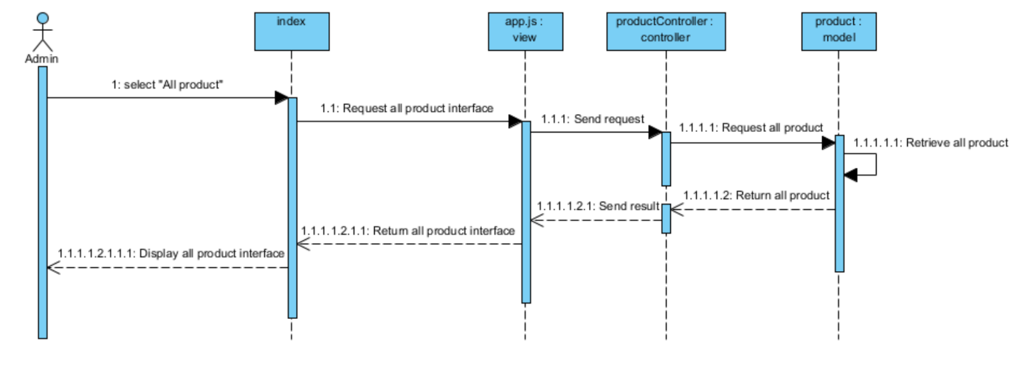

**Figure 26: SDW-03 View Product**

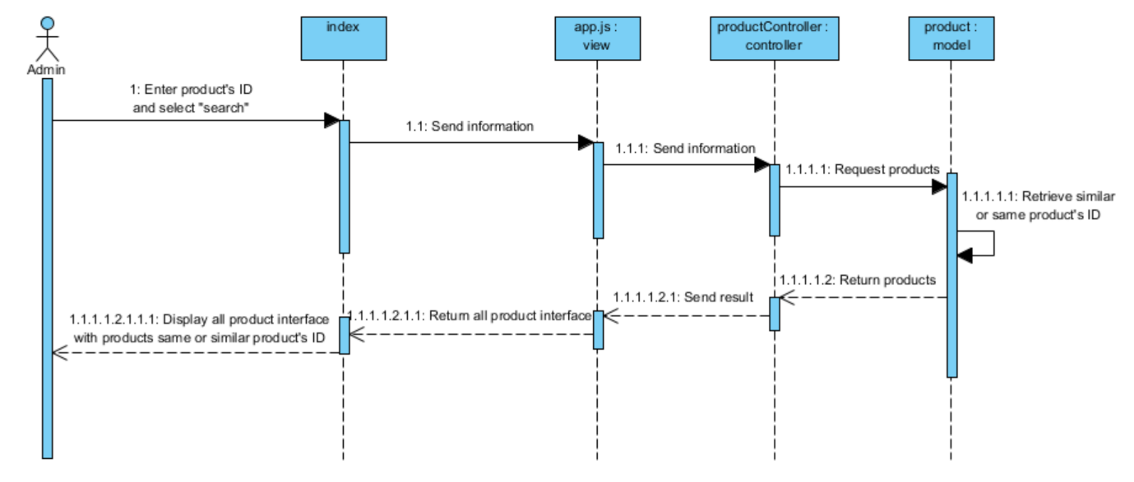

**Figure 27: SDW-04 Search Product by ID**

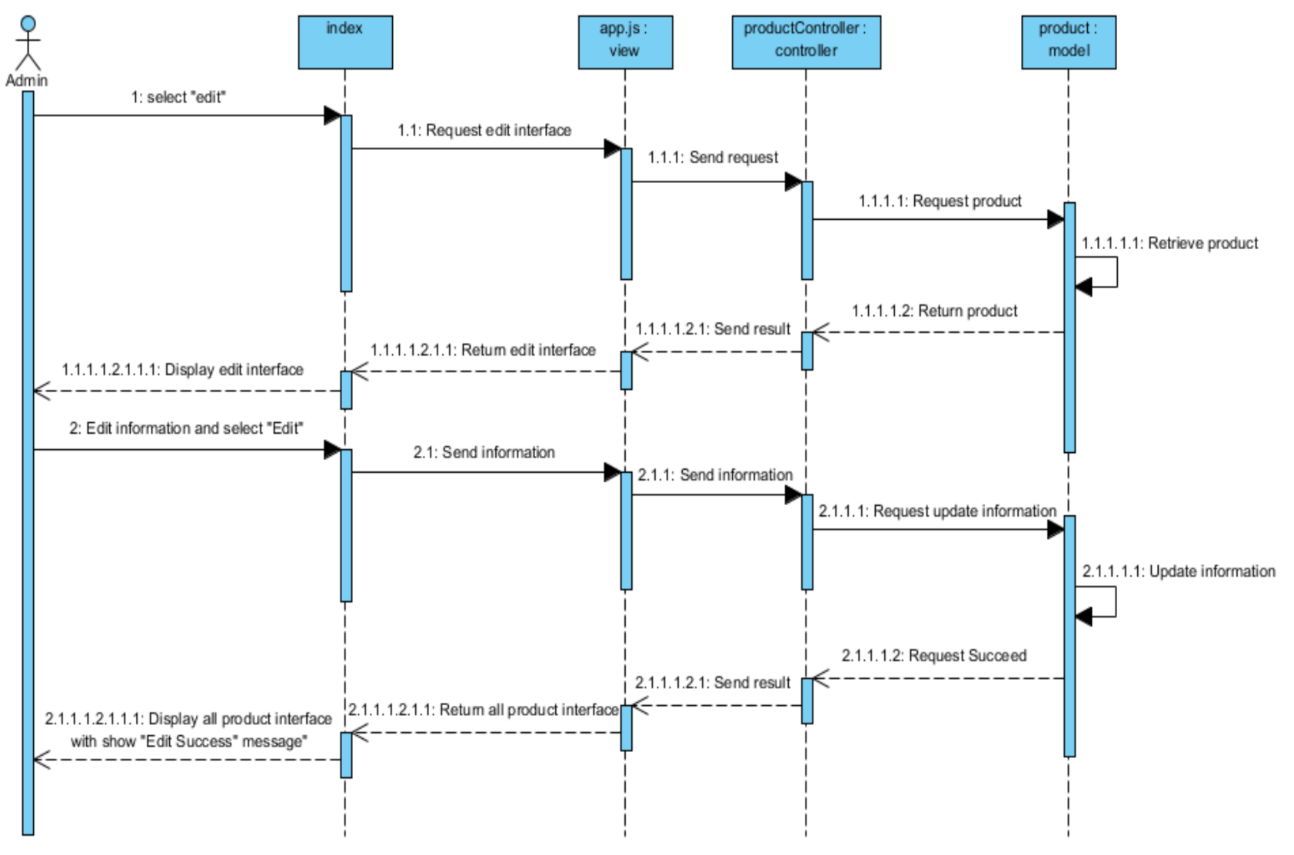

**Figure 28: SDW-05 Edit Product’s Information**

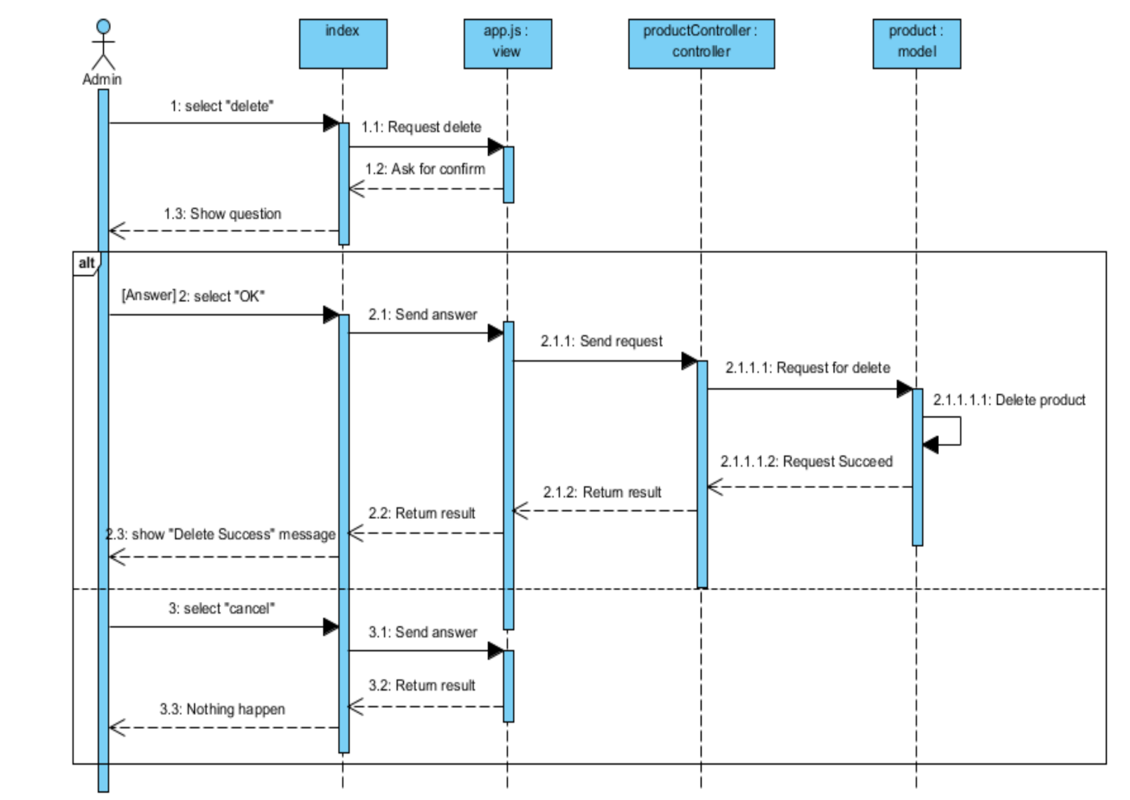

**Figure 29: SDW-06 Delete Product**

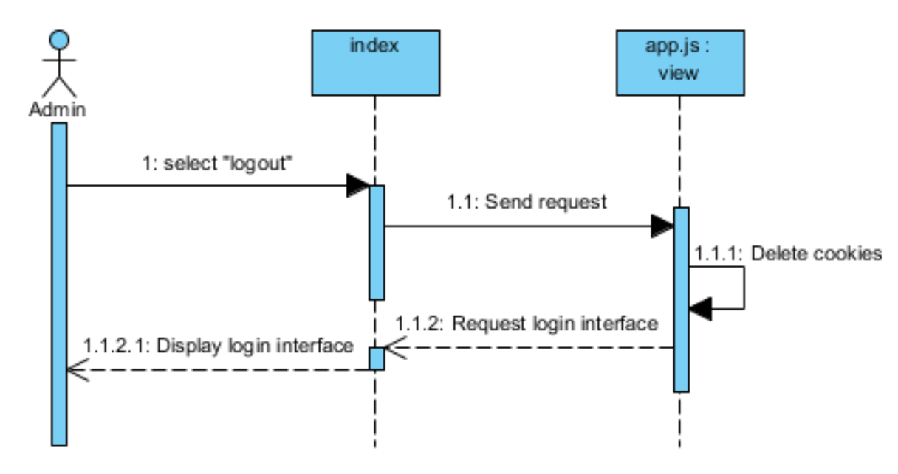

**Figure 30: SDW-07 Log Out**

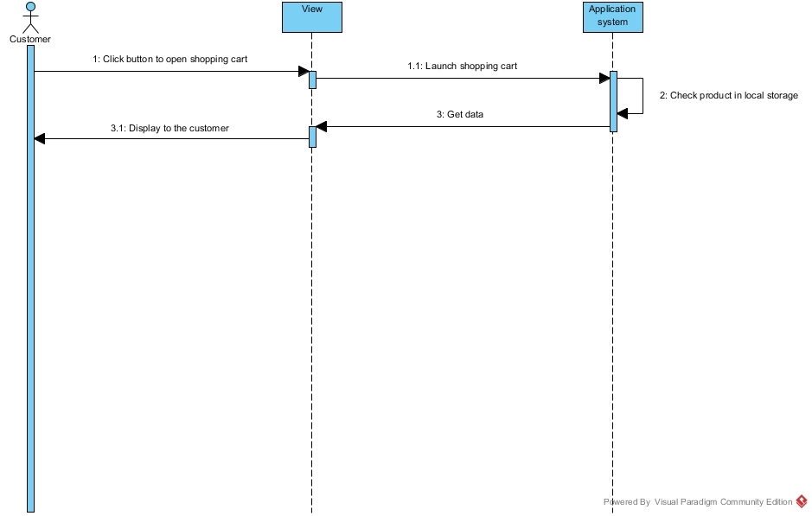

**Figure 31: SDA-01 View Product in Shopping Cart**

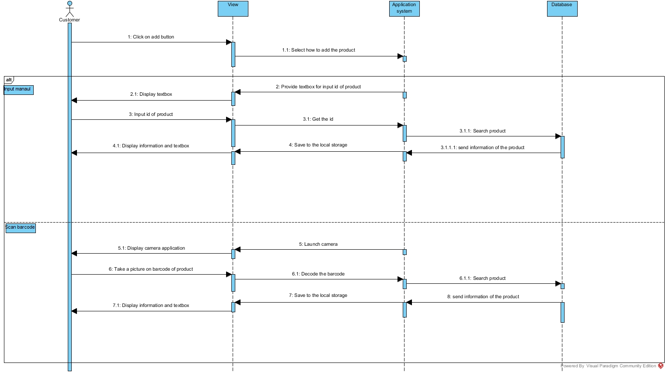

**Figure 32: SD-02 ADD Product in Shopping Cart**

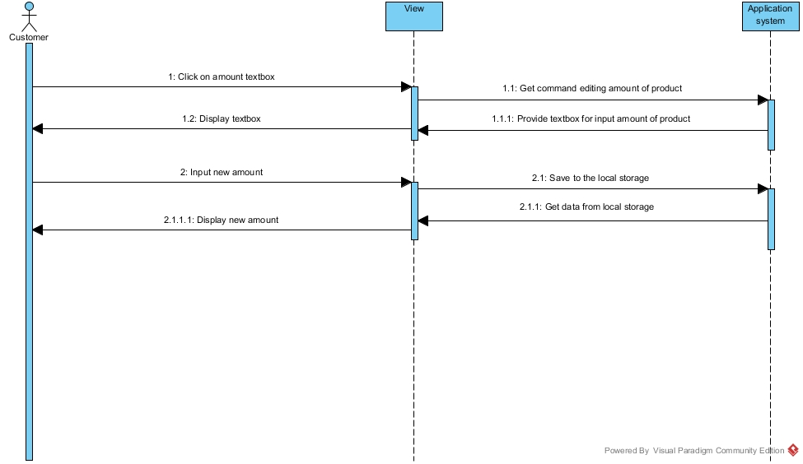

**Figure 33: SD-03 Edit Amount of Product in Shopping Cart**

## C:\Users\nexuspump\Downloads\Sequence Diagram Delete.jpg

**Figure 34: SDA-04 Delete Product from Shopping Cart**

1. **UI (Web Application)**

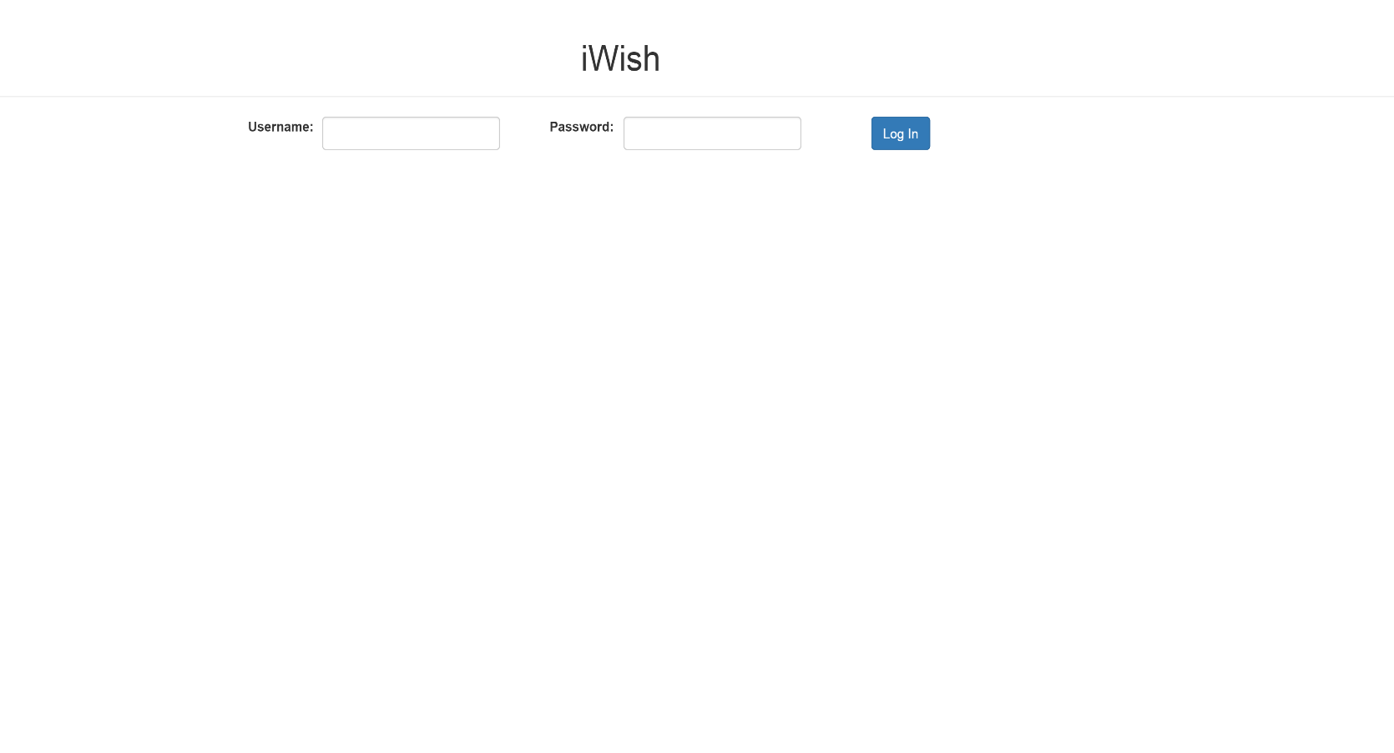

**Figure 35: UIW-01 Login**

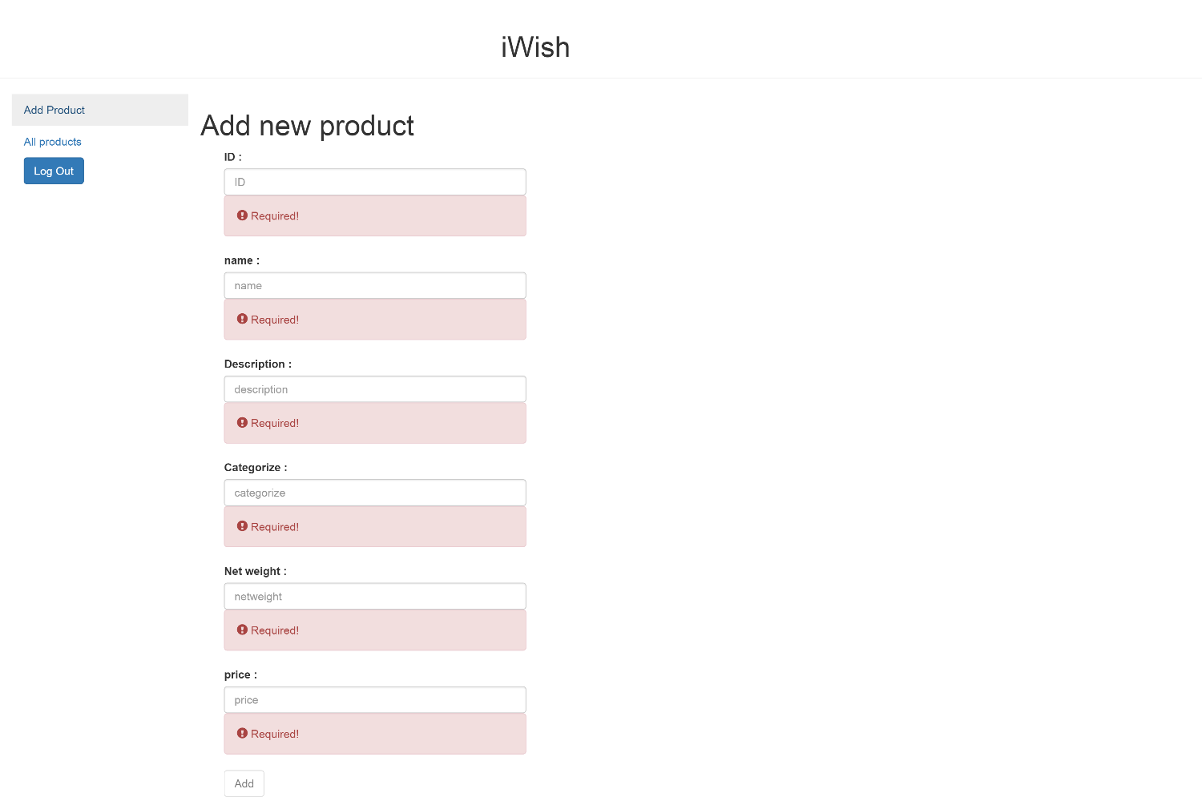

**Figure 36: UIW-02 Add Product**

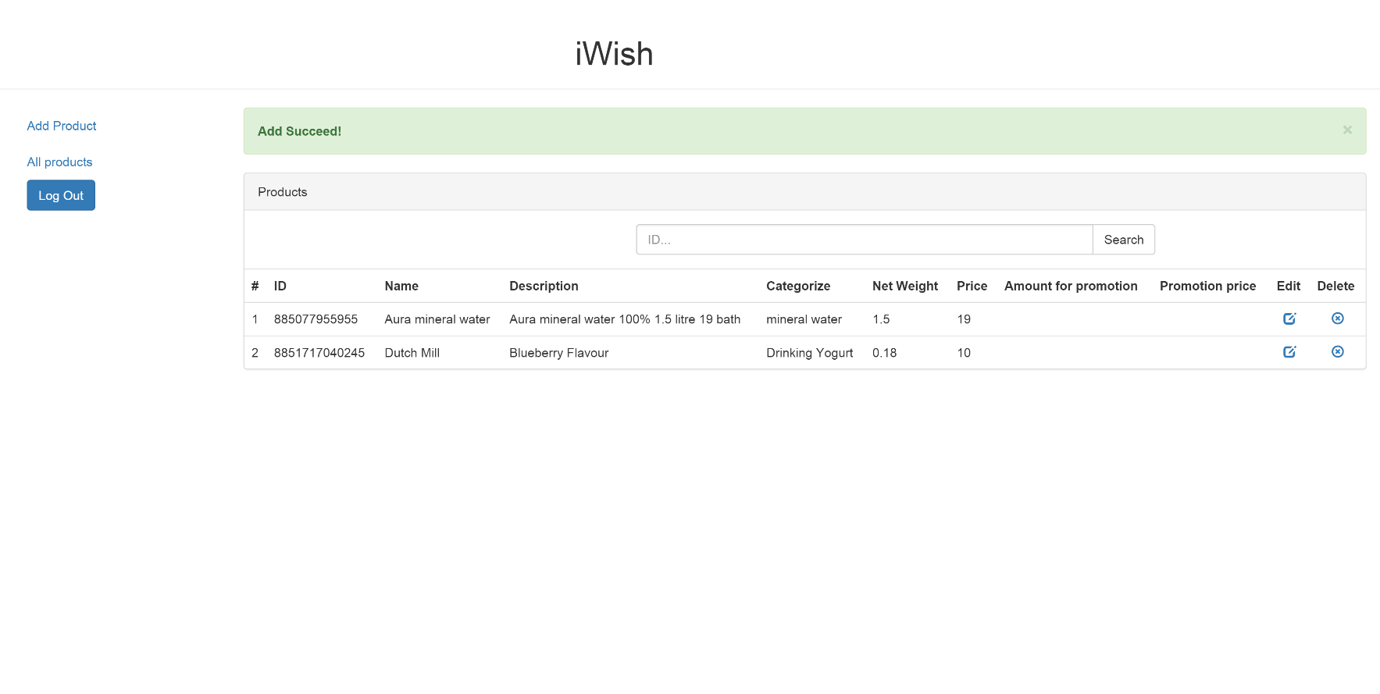

**Figure 37: UIW-03 Add Product Success**

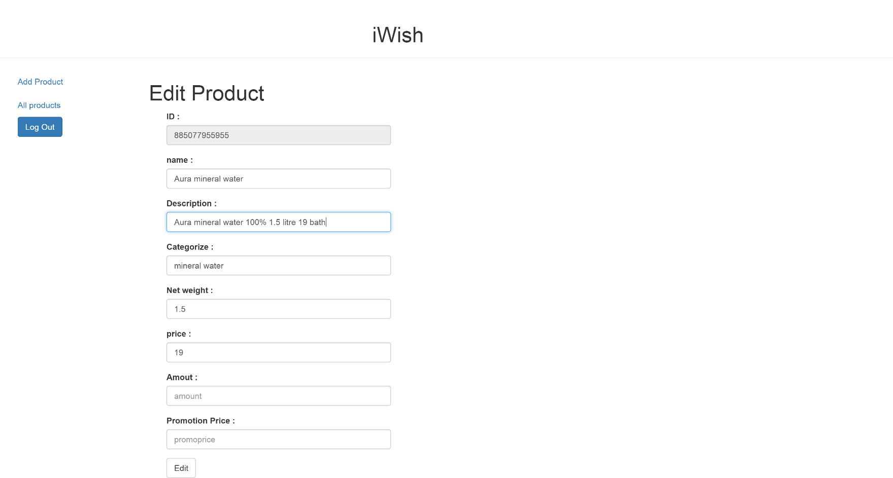

**Figure 38: UIW-04 Edit Information**

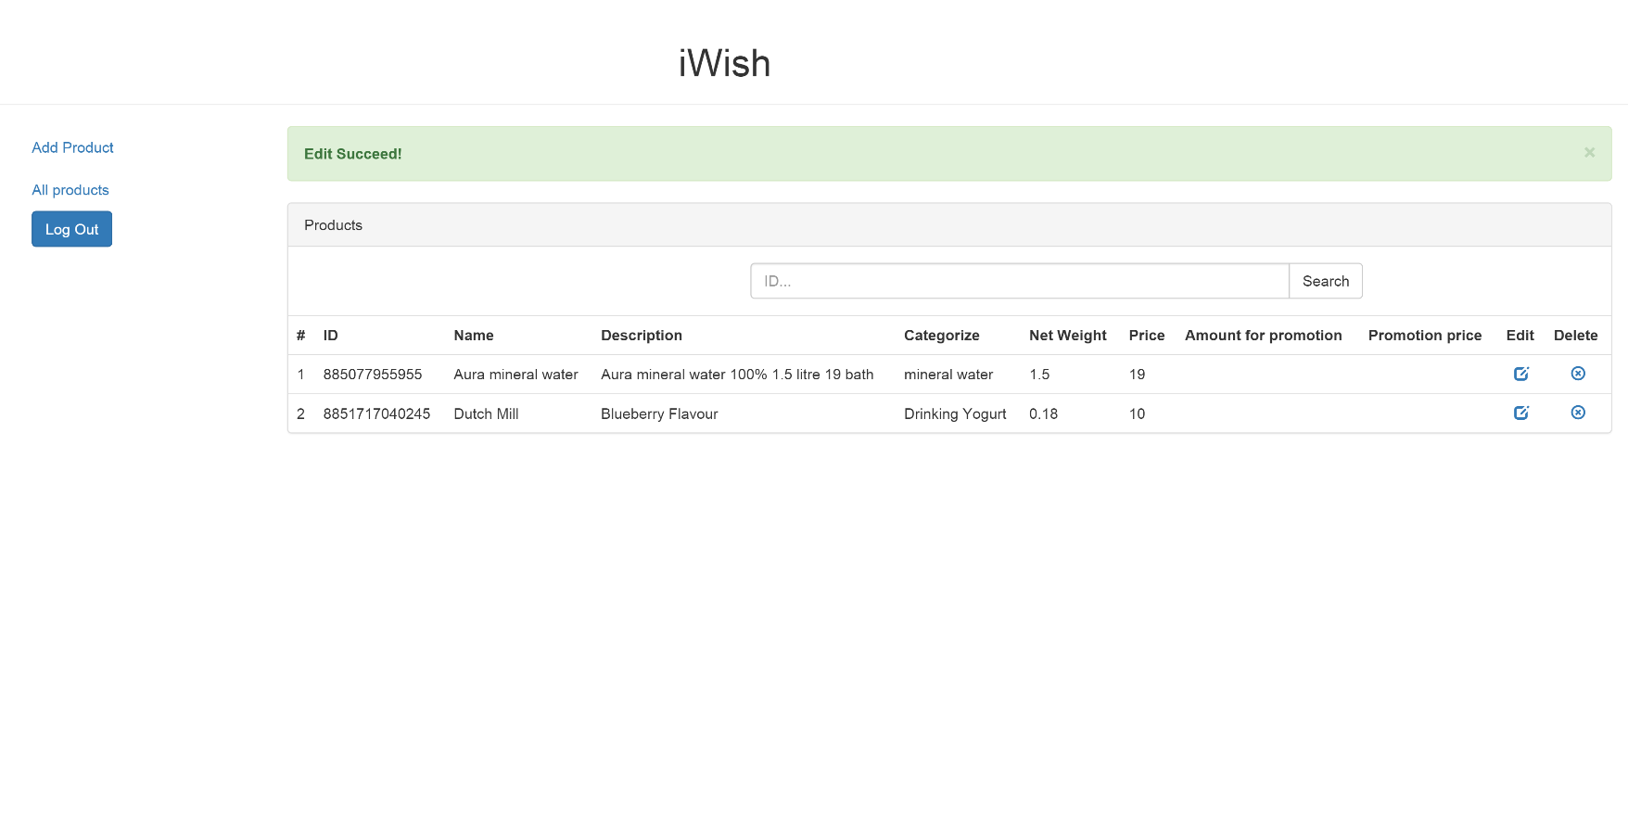

**Figure 39: UIW-05 Edit Success**

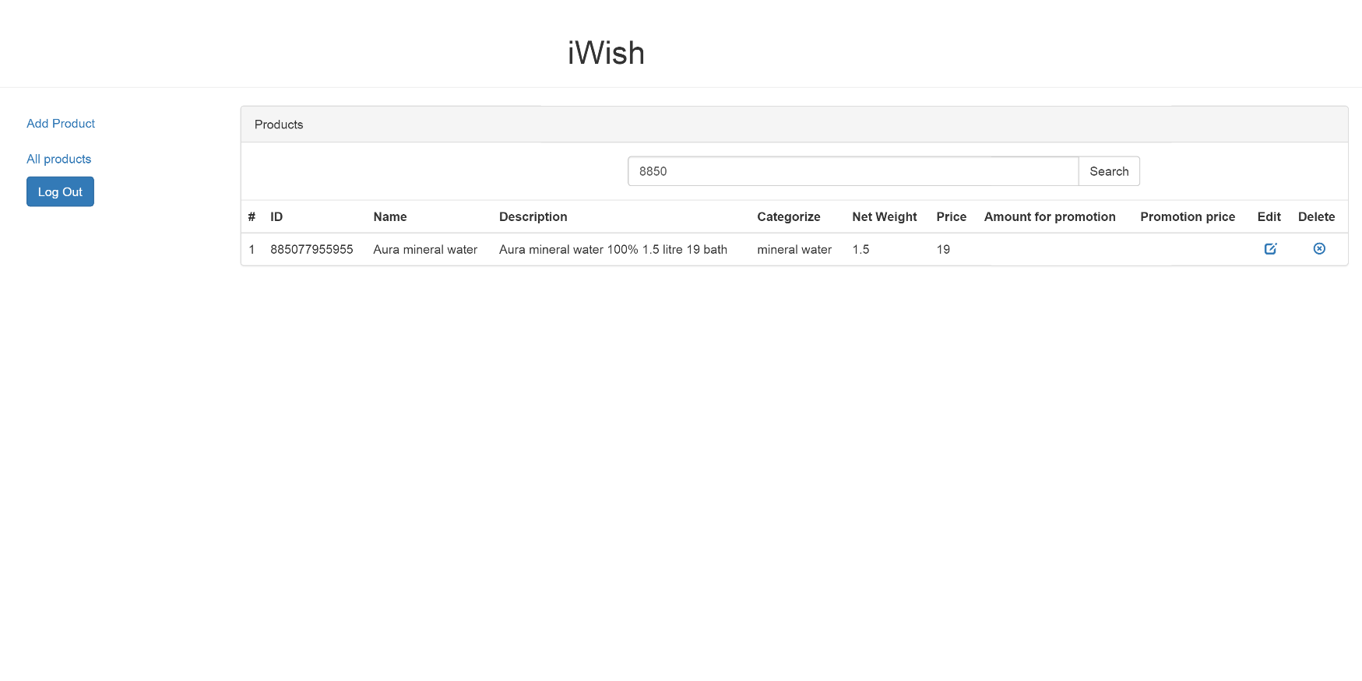

**Figure 40: UIW-06 Search Product**

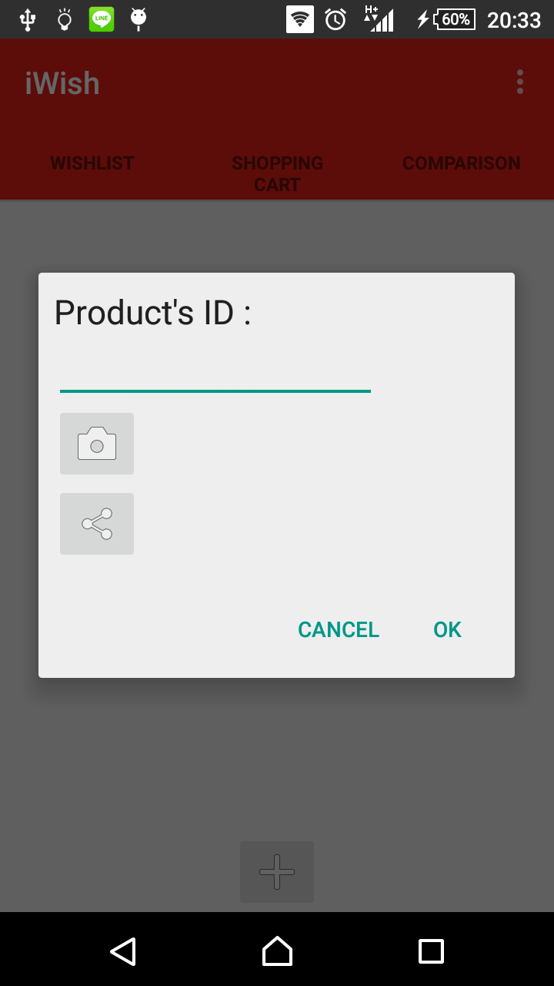

**Figure 41: UIA-01 Adding Dialog**

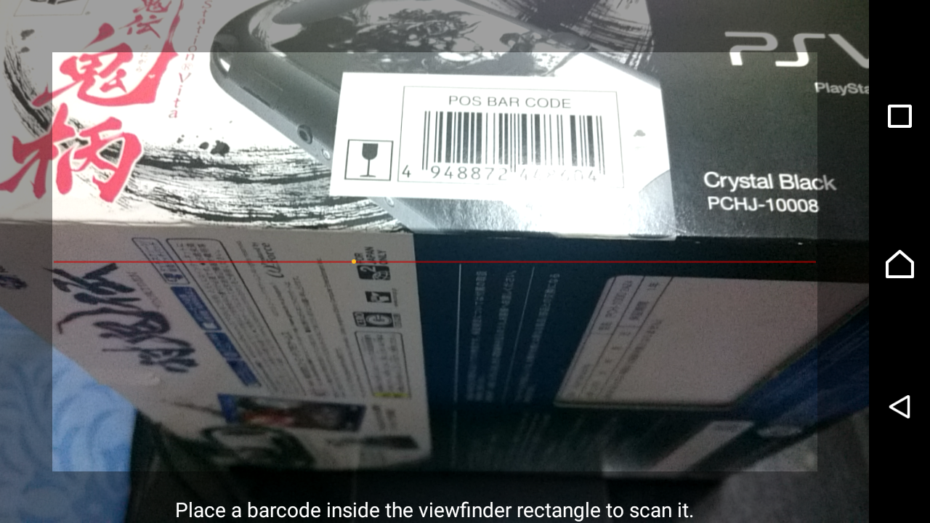

**Figure 42: UIA-02 Barcode Scanner**

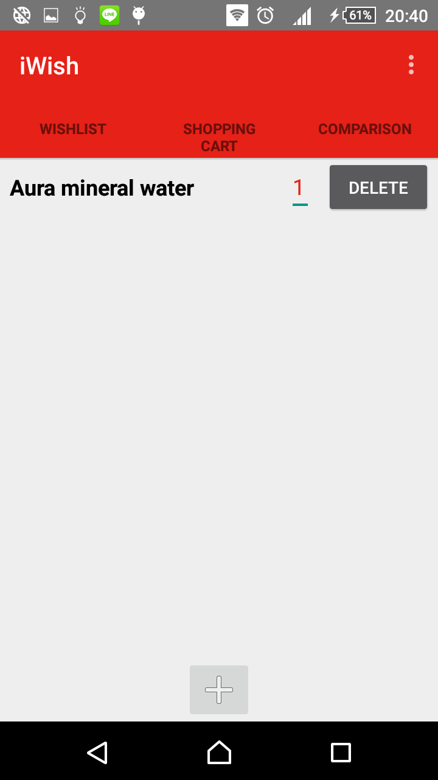

**Figure 43: UIA-03 View Shopping Cart**